Project Documentation
Python ->
- Flask -> Flask is a popular, lightweight web framework for Python that makes it easy to build web applications quickly.

  - Key Flask Concepts ->

    - Microframework -> Flask is called a "microframework" because it provides the essential tools to get a web app running, meaning it leaves out advanced features available in frameworks like “Django” etc. This gives us flexibility to only add what we actually need.

    - Routing -> Flask allows you to define URL routes, which map URLs to Python functions. When a user visits a URL, Flask routes the request to the corresponding function, which then processes the request and returns a response.

    - Request and Response Handling -> Flask provides tools for handling HTTP requests, including GET, POST, PUT, and DELETE methods. It also simplifies handling query parameters, form data, and cookies.

    - Template Rendering -> Flask uses Jinja2, a templating engine, to render HTML templates. This allows you to separate HTML from Python logic, making your code cleaner and your templates more flexible.

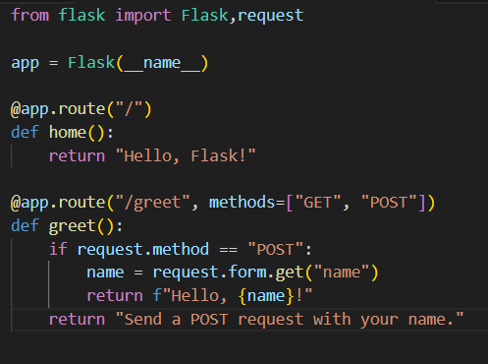

    - Example Flask App Structure ->
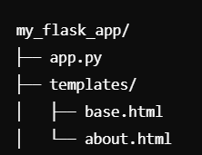

- Libraries ->

  - Requests -> The ‘requests’ library in Python is a powerful and user-friendly tool for making HTTP requests. It simplifies interactions with web services and APIs. In our project this library is mainly used for interaction with an API named Open-Meteo.

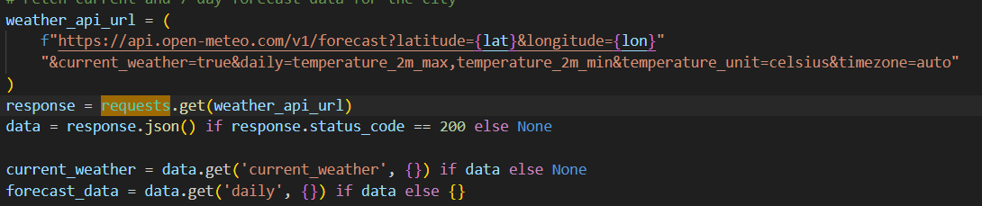

- Plotly -> Plotly is a versatile graphing library in Python that is used for creating interactive and visually appealing plots and dashboards. In our project it is used for creating Interactive Globe and 2d maps of countries.
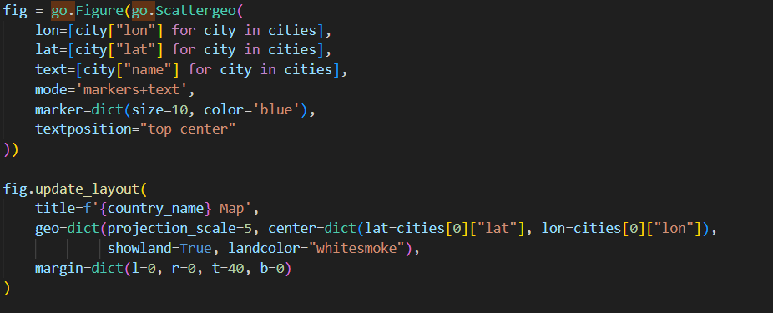
    - Figure -> The go.Figure function is used to define a figure in Plotly. You can provide data for the plot, along with layout options like titles, axes configurations, etc.

    - Scattergeo -> The scattergeo function in Plotly is used to create scatter plots on geographical maps. It allows you to plot points on a map using latitude and longitude coordinates. This is especially useful for visualizing data points in geographic locations (such as cities, countries, or other regions).
- Overview -> The Climate Snap-tracker is an interactive web application that provides users with global climate visualization tools, real-time weather data, and a sleek, user-friendly interface. Built using Flask as the backend framework and HTML/CSS for the front-end design, the project combines interactivity with dynamic data visualization.

  - Features ->
    - 3D Interactive Globe -> Users can explore countries on an interactive globe implemented with Plotly. - Clicking on a country redirects users to detailed weather information for that location.
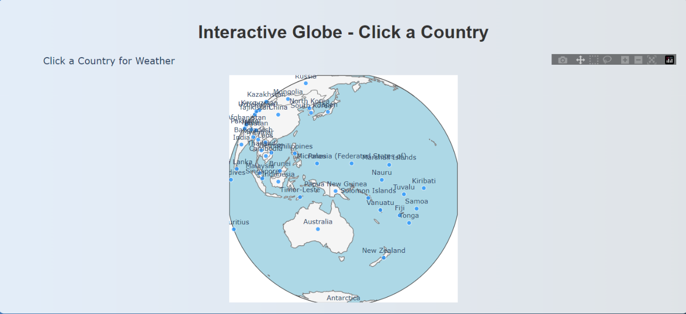

    - Weather Visualization ->
      - Displays real-time weather updates including temperature, wind speed, and wind direction.
      - Provides a temperature forecast with an integrated graph for better understanding trends.
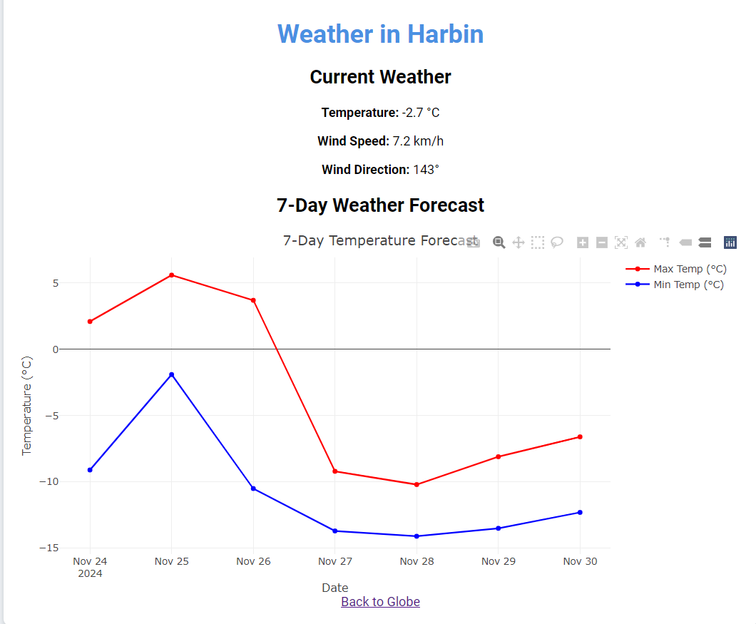

    - Navigation ->
      - Easy navigation through a Home, About, and Contact Us page.
      - Minimalistic and responsive design with a focus on usability.
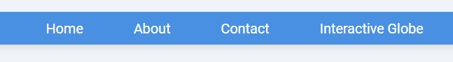

    - Contact Form ->
      - Users can submit feedback or queries via a simple contact form.

    - Custom Styling ->
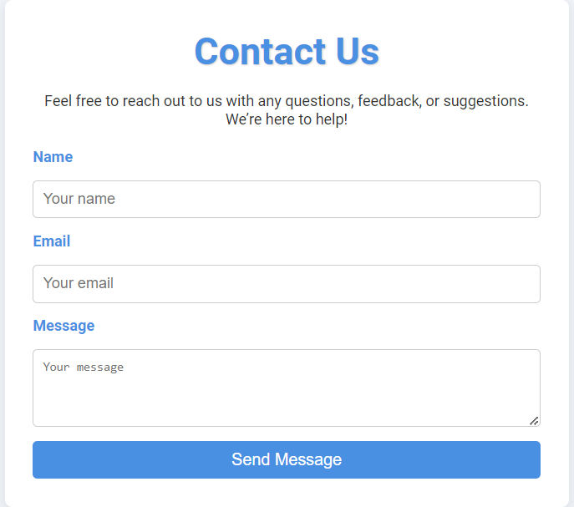
      - Unique, visually appealing designs for different pages.

  - Technology Stack ->
    - Backend ->
      - Python
        - Plotly for interactive visualization
        - Flask
        - Requests Library

    - Frontend ->
      - HTML, CSS
        - Responsive design with dynamic elements

    - API Integration ->
      - Potential for weather data APIs to enhance
real-time updates.

  - Future Enhancements ->
    - Include historical climate data visualization
    - Add user accounts for personalized experiences
    - Add more detailed climate information.

